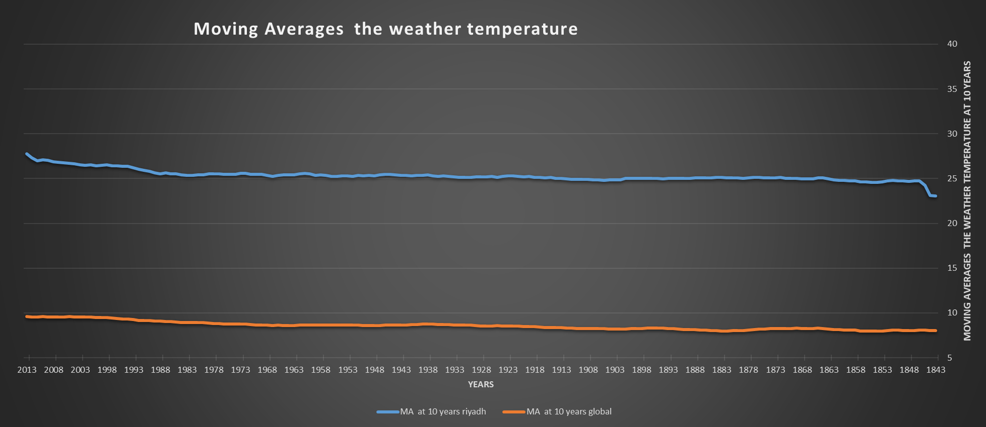

Is your city hotter or cooler on average compared to the global average?

You will notice that the temperature is high by comparing it with the global moving average, of course because of the desert environment

Has the difference been consistent over time?

yes ,but we are witnessing a slight increase in temperature, as shown in the 1990 chart in Riyadh, due to the increase in economic activity in the capital,

Have the local and global temperatures followed similar patterns?

yes s shown in the chart from 1850 to1960

What does the overall trend look like?

The curve will go up (exponential curve)

Is the world getting hotter or cooler?

The world will be hotter

Unfortunately yes , the temperature has risen dramatically over the years, causing environmental and human damage, and one of the main reasons for the temperature rise is the rapid development we are witnessing now.

Has the trend been consistent over the last few hundred years?

We note that the weather temperature is somewhat stable

How did you calculate the moving average?

The moving average was calculated every ten years by Excel

C2=AVERAGE(C2:C11)

C2= AVERAGE(C3:C12)

You can check the excel sheet

* + What tools did you use for each step?

Excel , and was used SQL to download data in a format CSV

1- City l_data

select*

from city_data

2- Global _data

select*

from global_data